IAM – Identity Synchronization Additional Requirements
- Requirement Specification
  - Requirement traceability
Requirement Specification Ref INT.00-11 – Requirement to develop and implement a web based user interface portal.
  - Requirement description
This Requirement Specification describes the need to create an ID Sync User interface Portal.
Within the Identity Synchronization project, FIM (Forefront Identity Manager) will primarily be used to deploy the ID Sync solution (supplied by Microsoft), however there is a requirement for an interface to manage other aspects of the solution including configuration, reporting, logging, searching and troubleshooting functionality.
The main requirements for the ID Sync Portal are to provide the following:
  - Configuration management
  - Basic reporting
  - Basic monitoring, logging, and troubleshooting
  - Multi-purpose Portal available for other IAM projects.

The diagram below provides a high level overview of the required functionality:
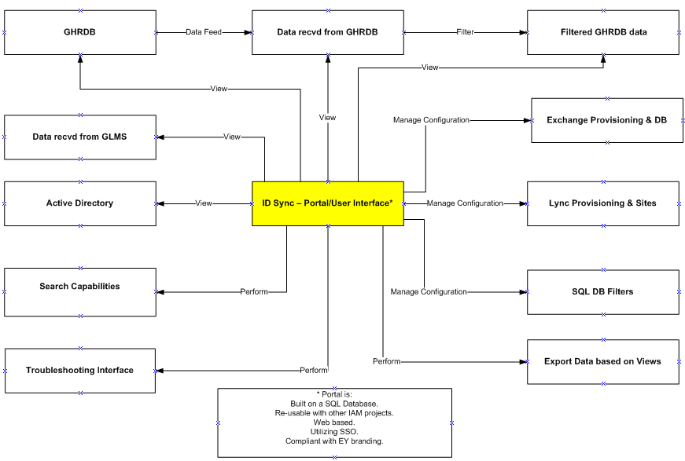

Once deployed the primary users of the ID Sync Portal will be the IT Services Operations Team.
  - Requirement details
- INT-00 Extensibility :
  - The interface should be extensible to include functionality related to other IAM projects.
Note: This document only deals with requirements related to ID Sync project.
- INT-01 Interface:
  - Interface should be a web application.
- INT-02 Appearance:
  - Interface should comply with the EY branding standards.
- INT-03 Authentication:
  - Provide SSO (Single Sign On).
- INT-04 Authorization:
  - INT-04.01: Provide ability to control access to interface functionality based on the user role.
  - INT-04.02: Develop role based access model.
Note: Authenticate users using SSO and then authorize using groups.
- INT-05 Read-Only views :
  - INT-05.01: Provide ability to display data from Global Human Resource (GHR) database ID Sync view. – Directly from GHRDB
  - INT-05.01a: Provide ability to display data from Global Human Resource (GHR) database ID Sync view. – Directly from GHRDB DataFeed
  - INT-05.02: Provide ability to display processed GHR data after necessary filters have been applied by ID Sync processes.
Following business rules apply to this requirement:
    - Filtered GHRDB data will be used by FIM as the source.
    - Application of filters will depend on the deployment phase:
      - Pilot: Multiple filters will be applied and records will be allowed to flow from specific countries, specific office locations, and specific Service lines. In short, filtering will be based on:
        - Countries
        - Office Locations
        - Service Lines
      - Phase 1: After the successful completion and validation of the Pilot phase complete office locations will be allowed. Filtering will be on:
        - Countries
        - Office Locations
      - Phase 2: Finally complete countries will be allowed to flow and filtering will only be on:
        - Countries
  - INT-05.03: Provide ability to view data from Global List Management System (GLMS) view that has been provided to ID Sync.
- INT-06 Searching:
Provide following searching capability in the ID Sync interface:
  - INT-06.01: Search GHR data view on:
    - Employee First Name
    - Employee Last Name
    - Employee GPN
    - Employee GUI
    - Internet email address
    - Country Code
  - INT-06.02: Search GHR Internal SSIS (SQL Server Integration Services) data view on:
    - Employee First Name
    - Employee Last Name
    - Employee GPN
    - Employee GUI
    - Internet email address
    - Country Code
  - INT-06.03: Search GHR filtered data on:
    - Employee First Name
    - Employee Last Name
    - Employee GPN
    - Employee GUI
    - Internet email address
    - Country Code
  - INT-06.04: Search GLMS data view on:
    - List Title
    - List Number
  - INT-06.05: Ability to lookup users in Active Directory (AD). Use following attributes in the lookup criteria:
    - givenName
    - sn
    - ey-HRGPN
    - ey-HRGUI
    - Internet email address
    - SamAccountName
    - UserPrincipalName
Access model related to AD attributes:
Role | Access
FIMAdmin | Read/Write Access to all User and configuration data
ID Sync Portal Admin | All non system user attributes with ability to export data.
Level 2 | All non system attributes but no ability to export data.
Level 1 | All non system and non confidential attributes with no export capability.

  - IN-06.06 Consolidated Search View
Require the ability to perform a search on the Users GHR attributes, which the displays the search results from INT-06.01– 06.05 in a single consolidated view.
Note INT-06.04 GLMS is excluded from the consolidated search view results requirement.
As a minimum require the individual search options as defined in INT-06.01-06.06.05 and as a maximum require the consolidated search view as defined in INT-06.06.

- INT-07 Read-Write (Configuration) views in ID Sync SQL database:
  - INT-07.01: Provide ability to manage following filters through the interface. These filters are stored as values in IDSync SQL database.
    - Countries
    - Office Locations
    - Service Lines
Interface should display current filters, if any, and then allow changing current ones and adding more to the list. Provide necessary data validation so that only allowed values can be used.
Drop downs
Display both code and description
Data populated will be based on the relationship between the provided criterion.
Portal to provide the ability to search configured countries.

  - INT-07.02: Provide ability to manage Exchange & Lync provisioning enablement by country.
Ability to add/edit countries
Provide confirmation in case of removal.
Columns Required: Param
Value

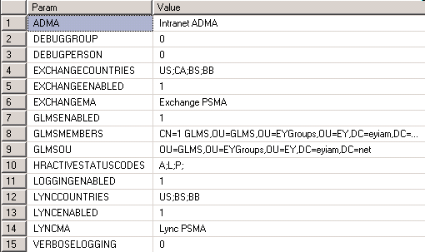

Updateable table by FIM Administrators.

Note: Depending on these configuration settings, FIM solution will decide whether to provision Exchange mailboxes and Lync accounts or not.

INT-07.03: Provide ability to specify country and site location where the Lync user should be provisioned.

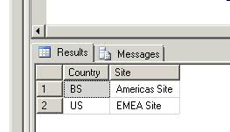

Updateable by FIM Administrators

Updateable by FIM Administrators

  - INT-07.04: Provide ability to manage Exchange database assignment per country and/or O365 cloud environment.
DAG -> On-prem
HostedNA, HostedEU -> Hosted (O365)
Maintained by M&C operational team (Access control)
Each country will only have one record
Both columns are required
Integrity check between this table and the Configuration table (FIMConfig)
Columns Required: Country
DB

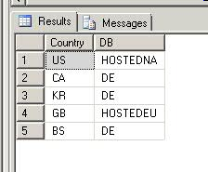

Many countries can be assigned to single site
Updateable table by FIM Administrators

  - INT-07.05: Provide ability to manage Lync sites assignment per country.

Many countries can be assigned to single site
Each country should have only one record
Updateable by FIM Administrators

- INT-08 Support/Troubleshooting Interfaces
  - INT-08.01: Provide ability to display transaction logs generated by Exchange mailbox provisioning scripts.
Columns Required: GPN
GUI
First Name
Last Name
EMAIL
ACTION
DN
COUNTRY
REQUEST_TIME
SUCCESS_TIME
RESULT

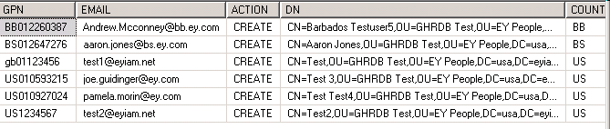
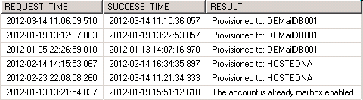

Readable by all levels.

  - INT-08.02: Provide ability to display transaction logs generated by Lync account provisioning scripts.
Columns Required: GPN
GUI
First Name
Last Name
EMAIL
ACTION
DN
COUNTRY
REQUEST_TIME
SUCCESS_TIME
RESULT

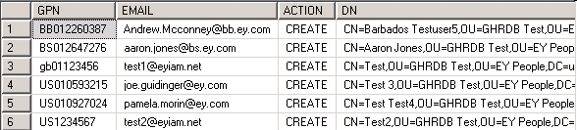
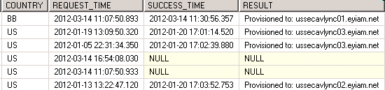

Readable by all Groups.

  - INT-08.03: Provide ability to display Exchange provisioning errors
Columns Required: First Name
Last Name
ID
Time
GPN
DN
Error

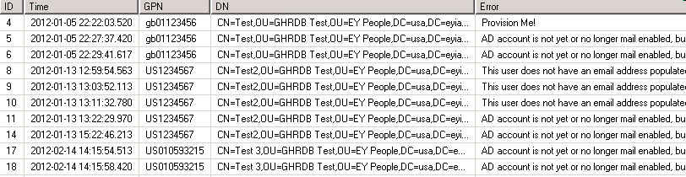

Readable by all Groups.

  - INT-08.04: Provide ability to display Lync provisioning errors

Columns Required: First Name
Last Name
ID
Time
GPN
DN
Error
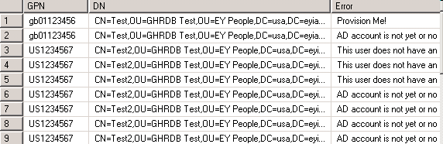

Readable by all Groups.

  - INT-08.05: Provide a view on all users who are not joined in FIM metaverse. - Only to be used as a Report, not a troubleshooting mechanism. Allow IAM Ops to export this information to Excel for reporting. Purpose is to allow IAM Ops proactively correct user data issues, either in AD or GHRDB.

- INT-09 Export: Provide ability to export data from display views based on the user access level.
- INT-10 IAM Interface/Portal: Informational: There is a desire to design this interface in such a manner that it can be used for other IAM projects. The following applies to this interface:
  - INT-10.01: A common interface/portal to manage all IAM projects.
  - INT-10.02: Provide role based access.
  - INT-10.03: Interface will provide capability to manage ID Sync configuration and other basic reporting and troubleshooting functionalities.
  - INT-10.04: Interface will contain links to Group Management end-user self-service portals.
  - INT-10.05: Interface will be used to manage Exchange contacts and shared mailboxes.
  - INT-10.06: Interface will be used to manage video endpoints for the Lync product.
Note: Not all requirements of INT-11.05 & .06 for this common interface are known at this time.

- INT-11 Audit/History Log: All edits need to be logged, detailing the following information in ‘read-only’ format:
  - Date
  - Time
  - What was updated, including the previous value prior to the update.
  - Who performed the update (Update can be performed by an authorized User or system)

  - Dependencies
The following dependencies exist to the specification of this feature:
- GHR data will be available through the GHRDB data view.
- GLMS data will be available through the GLMS data view.
- AD data will be available.
- Availability of configuration, logs, and other tables needed for the FIM solution.

  - Risks
The following risks are associated with the specification of this feature:
- The creation and maintenance of audit logs associated with each item of content may impact the performance of the application. (ie poor system response times).

  - Scope exclusions
The following items have been determined to be out-of-scope for the specification of this feature:
- Though there is a desire to use this interface for other IAM projects but specific requirements of other IAM projects are not known at this point and they will be considered out of scope from this document’s perspective.
- Though some of the configuration tables used in the FIM solution design will be available through this interface, but any direct change to FIM product and any associated design elements is out-of-scope for this requirement.
- The ID Sync User Interface Portal will not manage the migration of existing Users from Lotus Notes to MS Exchange, nor manage ‘rollback’ or ‘roll forward’ scenarios.
- The FIM MA's (Management Agents) will be viewed and managed directly through the FIM Sync Engine application, not through the ID Sync User interface portal.
- Requirement ‘Management Agent (MA) Execution: Display last MA run information’ is regarded as out of project scope.

  - Assumptions
The following assumptions are associated with the specification of this feature:
- The ID Sync User Interface Portal when initially deployed will not contain a ‘Help’ section.
- Response times from the Portal are acceptable (eg display search results <5 seconds).
- Business Continuity/Disaster Recovery is not required.
- INT-05.02 - Assumed the User can view the results where ‘Exchange’ has been enabled and filter via a drop down menu box by country and/or all.
- INT-06.01 To INT-06.03 – Assumed the User can view the search results as a side by side comparison.
  - Acceptance Criteria
Success of the IAM ID Sync User Interface Portal will be defined by the implementation of the Portal, plus its associated requirements, as detailed above. This will be measured during the Pilot and pre-deployment phases via QA and UAT Testing, to ensure the Users interactions with the Portal are behaving as expected.

  - Notes
- INT-06.05 Should access on Global Catalog based attributes; therefore we can access any domain controller that is also a Global Catalog to search across the forest. A standard ldap search is on port 389 or 636 (secure); however on a global catalog it is 3268/3269. Example: LDAP://ey.net:3268/dc=ey,dc=net.
- INT-07.02 Ability to modify parameter EXCHANGECOUNTRIES by adding an additional country separated by semicolon. Also updates to the table Controlled by FIM Admins right now, but may need flexibility to add Messaging and Collaboration folks; or the process will be they need to approve the additional country.
- INT-08 All troubleshooting tables should be searchable; by GPN, First name, Last name , email and country and date range; “instant search” feature would be nice or full text search; sortable.

- Open items
# | Logged by | Description | Date logged | Date resolved | Resolution | Status
1 | Waqar Ali | Confirm from IAM Program DA & steering committee that one IAM interface/portal will be developed to provide one common interface for all IAM programs. | 11-Feb-2012 | - | - | Open
  - Revision/verification history
Date | Version | Description | Author
11-Feb-2012 | 0.1 | Initial draft | Waqar Ali
14-Feb-2012 | 0.2 | Made changes based on the feedback provided by Afzaal Syed | Waqar Ali
5-Mar-2012 | 0.3 | Changes in progress | Waqar Ali
8–Mar-2012 | 0.4 | General updates | Waqar Ali
9-Mar-2012 | 0.5 | General updates following review meeting on 9th March. | Paul Barbour-Murrie
12-Mar-2012 | 0.6 | General updates following review meeting on 12th March. Addition of ‘Consolidated Search Results’ view requirement | Paul Barbour-Murrie
15-Mar-2012 | 0.7 | Transaction & Error log details updated (INT-08.01 To 08.04). Plus additional screen shots added.(INT-07.02 To 07.05) | Paul Barbour-Murrie
23-Mar-2012 | 1.0 | Incorporated comments from David. Requirement Specification base lined by David A. Cecil, Anthony Harper and Afzaal Syed | Paul Barbour-Murrie
18-Apr-2012 | 1.1 | Incorporated comments from Romer Hernandez and Marina Baron during review session with James Marsh, David Hannah and David A. Cecil | Paul Barbour-Murrie

